First Grade

2 Boxes of crayons, 24 count
24 #2 yellow pencils (sharpened, plain yellow)
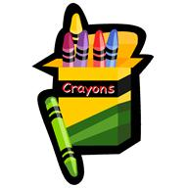
4 Large glue sticks
1 Bottle of liquid school glue 4oz.
2 Large pink erasers
1 Pair scissors, Fiskars recommended
1 Book bag
2 Boxes of tissues
1 4-pack/large Expo dry erase markers
1 Pack of Crayola washable markers
4 Plastic folders with pockets (1 red, 1 green, 1 blue & 1 purple)
3 Composition notebooks
1 Small plastic supply box
1 Old sock for dry erase board or small dry eraser
1 Set of headphones (small jack: No Beats or ear buds)

Girls Only: 1 Bottle of hand sanitizer & 1 roll paper towels
Boys Only: 1 Gallon size box of plastic bags & 1 container of Clorox wipes

Please put your child’s name on: crayon box, large erasers, book bag, plastic supply box, folders and notebooks.

